National Emphasis Program (NEP) on Amputation
OSHA issued a press release announcing that it has updated the National Emphasis Program (NEP) on Amputations in Manufacturing Industries (Amputations). This NEP will identify, reduce or eliminate workplace hazards associated with amputations in the manufacturing industries. Outreach is an essential part of this Emphasis Program.
Operating machinery or equipment continues to be extremely dangerous when they are not properly guarded or maintained. Injuries involving machinery or equipment often result in death or permanent disability.
The targeting strategy identified industries that have had been cited for machine guarding violations or industries that reported 50 or more amputation injury from or have a high injury rate. These industries are listed in Appendix B of the NEP Directive by NAICS (North American Industry Classification System).
It’s a great time to review machine guarding and Lockout procedures in your facility!!

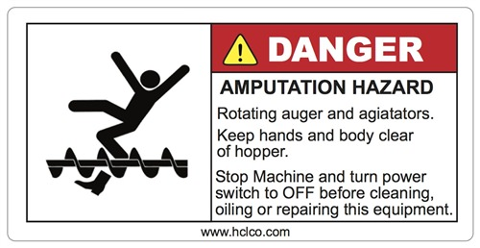
https://www.osha.gov/sites/default/files/enforcement/directives/CPL_03-00-022.pdf
https://www.osha.gov/OshDoc/data_General_Facts/amputation-factsheet.pdf
https://www.osha.gov/Publications/osha3120.pdf
https://www.osha.gov/SLTC/machineguarding/index.html

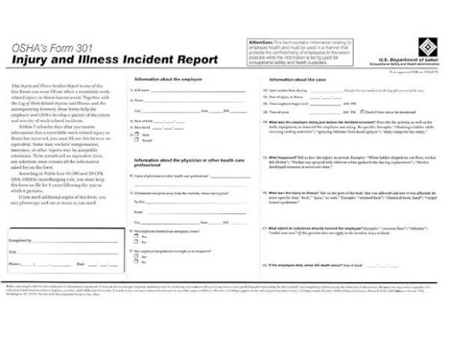
Post the OSHA Summary – 301 Form from February 1st – April 30th
Establishments with 20 or more employees must electronically report the OSHA Summary data by March 2, 2020

